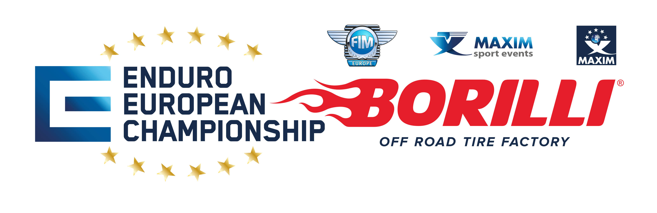

PRESS ACCREDITATION FORM 2023

Name of media:................................................................................................................................................... Type of media (online, print): ............................................................................................................................. First name: .............................................................. Last name: ................................................................... Job title:............................................................................................................................................................... Address: .............................................................................................................................................................. Post code: ................................................................ City: .............................................................................. Country: ................................................................... Telephone number: ..................................................... Email:...................................................................................................................................................................

require the accreditation for Enduro European Championship. This press accreditation form is valid for all the races of 2023.

1. STATEMENT: I am aware of the danger that motorsports in general (and rally in particular) entail and of the danger in following such events. Moreover, I state that I possess the professional training and experience needed to be able to follow the races of the event in question safely; and that I will use the utmost caution so as to avoid all physical harm or material damage; furthermore, I am aware of local, national and international regulations regarding the execution of my profession in the context of interest and commit to respect instructions and safety provisions in all parts of the race as instructed by Race Officials, Law and Order Units (Carabinieri, Polizia di Stato, etc.) and by the Staff of the race itself. I take all and every liability for any harm or damage I may cause to persons, animals and objects and relieve the Organizing Committee, the Clerk of the Course, Press Office Chief and any other person of the race Organization or any other Institution or Association as mentioned above of all Civil and Penal responsibility.
2. PRIVACY: I am aware that the data I have supplied are strictly confidential and I authorize the use of the same as laid down by Law for purposes related to this event.

.....................................................................................................................................................................

city / date / signature

DO YOU WANT TO RICEVE OUR EMAIL? YES NO